SOFTWARE REQUIREMENT SPECIFICATIONS

(SRS)

For the

Vending Machine Control System

(VMCS)

Contract No: …..

CDRL Sequence No: …..

Prepared For:

**Vimto Soft Drinks Company**

Prepared By:

**ADVANCED INFORMATICS SCHOOL (AIS)**

Authenticated by __________________ Approved by__________________

Vimto Soft Drink AIS

Date ___________________ Date __________________

# DOCUMENT APPROVAL

|  |  |  |
| --- | --- | --- |
|  | **Name** | **Date** |
| Verified by:  ________________________  Project Leader |  |  |
| Authenticated by:  ________________________  Project Manager |  |  |
| Approved by:  ________________________  Client |  |  |

Software: Microsoft Word 2010

Software: Enterprise Architect 8.0.864

Archiving place: C:\ (*Where you place an archive*)

Copies available: .DOCX, .PDF, .EAP format and CD-ROM

# REVISION HISTORY

|  |  |
| --- | --- |
| **revision** | **description** |
| **A** |  |
| **B** |  |
| **C** |  |
| **D** |  |
| **E** |  |

|  |  |  |  |  |
| --- | --- | --- | --- | --- |
| **Ind.+ Date** | **A** | **B** | **C** | **D** |
| **Written by** | MIMI SAFINAZ JAMALUDDIN | POUYA JAVADZADEH | JAMMEL MONA | MAZIDAH BINTI MAT REJAB |
| **Verified by** |  |  |  |  |
| **Authenticated by** |  |  |  |  |
| **Approved by** |  |  |  |  |

# LIST OF EFFECTIVE PAGES

|  |  |  |  |
| --- | --- | --- | --- |
| PAGES | REVISION | PAGES | REVISION |
|  |  |  |  |

# TABLE OF CONTENTS

DOCUMENT APPROVAL i

REVISION HISTORY ii

LIST OF EFFECTIVE PAGES iii

TABLE OF CONTENTS iv

1 SCOPE 1

1.1 Identification 1

1.2 Overview of the System 1

1.3 Overview of the Documents 1

2 APPLICABLE DOCUMENTS 2

2.1 Government Documents 2

2.2 Non-Government Documents 2

2.3 Contractual documents 2

2.4 Non-contractual document 2

3 ENGINEERING REQUIREMENTS 4

3.1 CSCI External Interface Requirements 4

3.1.1 Interface Customer/ CSCI VMCS 4

3.1.2 Interface Maintainer/ CSCI VMCS 4

3.1.3 Interface Simulator /CSCI VMCS 5

3.2 CSCI Capability Requirements 6

3.2.1 Simulate Control Panel Use Case *(SRS_REQ_100)* 7

3.2.2 Buy Drinks Use Case *(SRS_REQ_200)* 10

3.2.3 Login Use Case *(SRS_REQ_300)* 14

3.2.4 Maintain Vending Machine Use Case *(SRS_REQ_400)* 16

4 CSCI Internal Interfaces 20

4.1 CSCI Data Element Requirements 21

4.1.1 Boundary Classes 21

4.1.2 Entity Classes 22

4.1.3 Control Classes 22

4.2 Adaptation Requirements 23

4.3 Sizing and Timing Requirements 23

4.4 Safety Requirements 23

4.5 Security Requirements 23

4.6 Design Constraints 23

4.7 Requirements Traceability 24

5 QUALITY ASSURANCE 27

6 PREPARATION FOR DELIVERY 28

7 NOTES 29

ANNEX 30

LIST OF FIGURES

Figure 1: Use Case External Interface Diagram 4

Figure 2 : Use Case Diagram of CSCI VMCS 6

Figure 3 : Simulate Control Panel Use Case 7

Figure 4 : Buy Drinks Use Case 10

Figure 5 : Login Use Case 14

Figure 6 : Maintain Vending Machine Use Case 16

Figure 7 : VMCS Class Diagram 20

Figure 8: Buy Drinks Sequence Diagram 30

**Figure 9: Login Sequence Diagram** 31

**Figure 10: Maintain Vending Machine Sequence Diagram** 31

**Figure 11: Simulate Control Panel Sequence Diagram** 32

**Figure 11: Buy Drinks Sequence Diagram** 33

**Figure 12: Buy drinks Activity Diagram** 34

**Figure 13: Login Activity Diagram** 34

**Figure 14: Maintain Vending Machine Activity Diagram** 35

**Figure 15: Drink query Activity Diagram** 36

**Figure 16: Update price Activity Diagram** 36

**Figure 17: Total money query Activity Diagram** 37

**Figure 18: Collect all cash Activity Diagram** 37

**Figure 19: Update drinks Activity Diagram** 37

**Figure 20: Denomination query Activity Diagram** 38

**Figure 21: Update denomination Activity Diagram** 38

**Figure 22: Update VMCS Activity Diagram** 39

**Figure 21: Update denomination Activity Diagram** 39

**Figure 24: Update VMCS Activity Diagram** 40

**Figure 25: Simulate Control Panel Activity Diagram** 41

**Figure 26: Begin Simulation Activity Diagram** 42

LIST OF TABLE

Table 1 : Traceability Requirements Matrix 26

# SCOPE

The function of this system will be control of operation of the vending machine. It will control interaction with customers and display information to and carry out the instructions of the maintainer.

## Identification

System Number :

System Name : Vending Machine Control System

CSCI Identification Number :

CSCI Title : Vending Machine Control System

CSCI Abbreviation : VMCS

## Overview of the System

**Purpose of the VMCS:**

1. The purpose of this document is to specify the user requirement for the Vending Machine Control System (VMCS) for the Vimto Soft Drinks Company.
2. This document describes required system facilities and system performance characteristics.

**Purpose of the VMCS CSCI:**

1. To establish the user requirements for the VMCS and the simulator.
2. To provide the basis understanding of development for the system.
3. To determine scope of the system that meets the user requirement.
4. To identify the system capacity and the requirement for future expansion.

## Overview of the Documents

This document describes the interaction between the actors with the CSCI VMCS. Analysis of the requirements applying to VMCS relies on an OOAD UML notation using the Rational Rose Enterprise Edition 2000 tool. Certain elements resulting from this analysis are presented in this document.

# APPLICABLE DOCUMENTS

The following documents, for which the exact is indicated, form part of the specification as far as everything specified hereafter is concerned. In the event of a discrepancy between the documents referred to here and the content of this specification, it is the content of the specification, which should be considered to be the background reference.

Copies of specifications, standards, drawings and publications requested by suppliers in contact with the specified supplying functions may be obtained by contacting the contracting agency or directly through the contracting office.

## Government Documents

[1] DoD-Std-2167A Defense System Software Development

[2] DoD-Std-2168 Defense System Software Quality Program

[3] MIL-Std-1521B Technical Reviews and Audits

## Non-Government Documents

[4] IEEE Std.1233 IEEE Guide for Developing System Requirements Specifications

[5] IEEE Std.830 IEEE Recommended Practice for Software Requirements Specifications

## Contractual documents

## Non-contractual document

[6] RDL-101 General Thomson Software Development Reference System

[7] RDL-105 Conduct of Reviews and Audit Guide

Thomson Software Development Reference System

[8] RDL-318 SDP Drafting Guidelines

Thomson Software Development Reference System

[9] IRS (VMIVMCS/TR. 1.1) Interface Requirement Specification of CSCI VMCS

[10] UML Superstructure Object Management Group (2010), Unified Modeling Language (OMG UML 2.3), Superstructure (10-05-05)

# ENGINEERING REQUIREMENTS

## CSCI External Interface Requirements

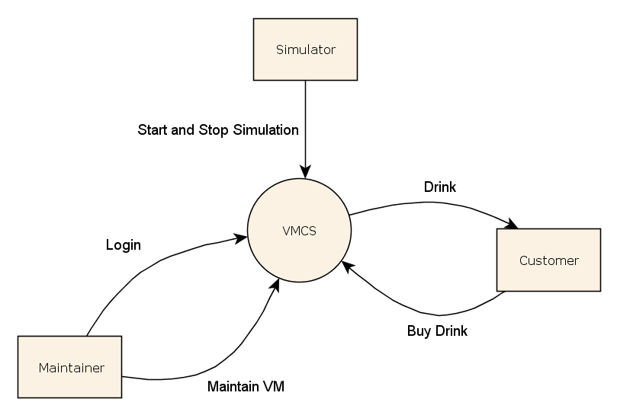

Figure : Use Case External Interface Diagram

### Interface Customer/ CSCI VMCS

Interface Identification : Customer

Interface Type : Person

**Description**

The customer is an actor who uses the VMCS to buy drinks

**Association**

This actor communicates with the Buy Drinks Use Case.

### Interface Maintainer/ CSCI VMCS

Interface Identification : Maintainer

Interface Type : Person

**Description**

The maintainer is an actor who uses the VMCS in order to maintain the VM. The maintainer have to login before start maintaining the VM.

**Association**

This actor communicates with the Maintain Vending Machine and Login Use Cases.

### Interface Simulator /CSCI VMCS

Interface Identification : Simulator

Interface Type : Person

**Description**

The simulator is an actor who uses the VMCS to simulate the control system.

**Association**

This actor communicates with the Simulate Control System Use Case.

## CSCI Capability Requirements



Figure : Use Case Diagram of CSCI VMCS

### Simulate Control Panel Use Case *(SRS_REQ_100)*



Figure : Simulate Control Panel Use Case

#### Brief Description

The Simulate Control Panel Use Case provides the capability to begin or end simulation, activate CIP or Maintainer Interface Panel or MISP.

#### Characteristic of Activation

This use case is initiated by the simulator.

#### Pre-condition(s)

1. The machine power should be switched on.
2. The VM should be locked.
3. OSCP should be loaded.

#### Description

##### Basic Flow

1. The Simulate Control Panel Use Case begins when the simulator selects “BEGIN SIMULATION”. ***(SRS_REQ_101)***
2. Once the simulator pressed the “BEGIN SIMULATION”, the VMCS will:
   1. Enables the following:
      1. “END SIMULATION” button.
      2. “ACTIVATE CUSTOMER INTERFACE PANEL” button.
      3. “ACTIVATE MAINTAINER INTERFACE PANEL” button.
   2. Disables the following:
      1. “ACTIVATE MACHINERY INTERFACE SIMULATION PANEL” button.
3. The VMCS allows the simulator to do the following operations

**[A1] - End Simulation**

**[A2] - Activate CIP**

**[A3] - Activate MIP**

1. The Simulate Control Panel Use Case ends here.

##### Exception Flow

Not applicable

##### Alternative Flow

**[A1] - End Simulation *(SRS_REQ_102)***

1. The simulator presses the “END SIMULATION” on the OSCP.
2. Once the simulations ends, there will no record kept of the simulated transactions.
3. The Simulate Control Panel Use Case ends here.

**[A2] - Activate CIP *(SRS_REQ_103)***

1. The simulator presses the “ACTIVATE CUSTOMER INTERFACE PANEL” on the OSCP.
2. The CIP will be displayed.
3. The Simulate Control Panel Use Case continues.

**[A3] – Activate** **MIP *(SRS_REQ_104)***

1. The simulator presses the “ACTIVATE MAINTAINER INTERFACE PANEL” on the OSCP.
2. Once the maintainer input the valid password, VMCS will:
   1. Enable the “ACTIVATE MACHINERY INTERFACE SIMULATION PANEL” ***(SRS_REQ_105)***
   2. Disable the “ACTIVATE CUSTOMER INTERFACE PANEL”
3. The Simulate Control Panel Use Case continues.

#### Post-condition(s)

1. The selected button shall activate and start simulation accordingly.

#### Rule(s) and Constraint(s)

1. Only simulator or customer or maintainer can use the VM once at the same time.

#### GUI

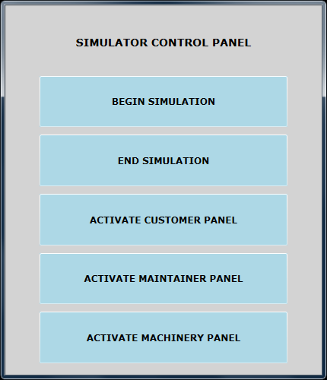

#### Notes

### Buy Drinks Use Case *(SRS_REQ_200)*



Figure : Buy Drinks Use Case

#### Brief Description

The Buy Drinks Use Case provides the capability to buy drinks for the customer.

#### Characteristic of Activation

The Buy Drinks Use Case is initiated by the customer.

#### Pre-Condition

1. The machine should not be under the maintenance.

#### Description

##### Basic Flow

1. The Buy Drinks Use Case begins when the customer selects a drink brand. ***(SRS_REQ_201)***

**[A1] - Terminate Transaction *(SRS_REQ_202)***

1. The VMCS will display and the price to the customer, provided that the selected brand was available. ***(SRS_REQ_204), (SRS_REQ_205)***

**[E1] - Brand Not Available**

1. The customer will insert the money and VM receives the money. ***(SRS_REQ_203)***

**[A1] - Terminate Transaction**

1. The VMCS will validate inserted money. ***(SRS_REQ_208)***

**[E2] - Invalid money**

1. The VMCS monitors and calculates the accumulative amount of money inserted by the customer, and displays the accumulated amount to the customer. ***(SRS_REQ_206),* *(SRS_REQ_209),* *(SRS_REQ_214)***

**[E3] - Not enough money**

**[A1] - Terminate Transaction**

1. If TOTAL_ACCUMULATED_MONEY >= SELECTED_PRICE the VMCS will disable the money slot. ***(SRS_REQ_215),* *(SRS_REQ_216)***
2. The VMCS dispense the selected drink to the customer.
3. The VMCS calculate the change and return it to the customer if there was any. ***(SRS_REQ_213)***

**[E4]- Insufficient denomination**

1. The Buy Drinks Use Case ends here.

##### Alternative Flow

**[A1] - Terminate Transaction *(SRS_REQ_212)***

1. Customer press the terminate button.
2. If the customer already inserted money, then the VMCS will return the money back to the customer.
3. The VMCS will terminate the transaction.
4. The VMCS will not keep the record of terminated transaction.
5. The Buy Drinks Use Case ends here.

##### Exception Flow

**[E1] – Brand Not Available**

1. If selected drink is not available, the VMCS will display “NOT IN STOCK” message.
2. The VMCS will waits for the customer to choose an available brand.
3. The Buy Drinks Use Case continues.

**[E2] – Invalid money *(SRS_REQ_210)***

1. If the money is not valid, the VMCS will display “COINS NOT VALID” message to the customer. ***(SRS_REQ_211)***
2. VMCS will reject the invalid money to the customer.
3. The Buy Drinks Use Case continues.

**[E3] – Not enough money *(SRS_REQ_207),* *(SRS_REQ_217)***

1. If TOTAL_ACCUMULATED_MONEY < PRICE, the VMCS shall not respond to customer request.
2. The VMCS shall wait for further money from the customer.
3. The Buy Drinks Use Case continues.

**[E4] - Insufficient denomination *(SRS_REQ_218)***

1. If it is impossible to return appropriate change to the customer, the VMCS will displays “NO CHANGE AVAILABLE”
2. The Buy Drinks Use Case ends here.

#### Post Condition(s)

At the end of successful transaction

1. The transaction shall be recorded by the VMCS. ***(SRS_REQ_219)***
2. The drinks shall be dispensed to the customer.

#### Rules(s) and Constraint(s)

1. TOTAL_ACCUMULATED_MONEY = TOTAL_ACCUMULATED_MONEY + INSERTED_MONEY
2. CHANGE_MONEY = TOTAL_ACCUMULATED_MONEY - PRICE
3. Only one drink can be bought per transaction
4. The VM accept only RM 0.10, RM 0.20, RM 0.50 RM 1.00.

#### GUI

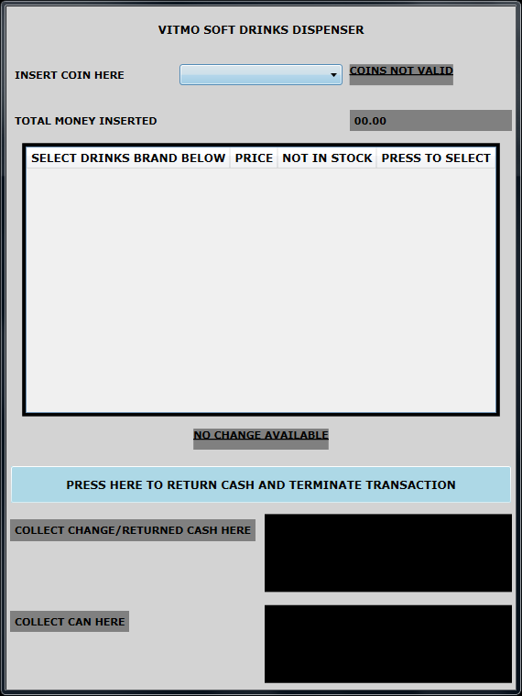

#### Notes

### Login Use Case *(SRS_REQ_300)*



Figure : Login Use Case

#### Brief Description

The Login Use Case provides the capability to access to the VMCS.

#### Characteristic of Activation

The Login Use Case is initiated by the maintainer.

#### Precondition

1. The VM door must be locked.

#### Description

##### Basic Flow

1. The Login Use Case begins when the maintainer entered the password. ***(SRS_REQ_301),* *(SRS_REQ_303)***

**[E1] - Invalid password**

1. Once the maintainer has been authorized the VMCS shows “PASSWORD VALID” and consequently the VMCS will change the door status to “UNLOCK” and it enable MISP and disable the CIP.. ***(SRS_REQ_302), (SRS_REQ_304), (SRS_REQ_305),* *(SRS_REQ_306)***

**[E2] – Purchase in progress**

1. The Login Use Case ends here.

##### Alternative Flow

Not Applicable

##### Exception Flow

**[E1] – Invalid Password**

1. The VMCS will display “PASSWORD INVALID”
2. The Login Use Case continues.

**[E2] – Purchase in progress *(SRS_REQ_307)***

1. If customer was in any stage of Buy Drinks Use Case except step VII onward the VMCS should rollback the transaction and return the money to the customer.
2. The Login Use Case continues.

#### Post-condition(s)

1. The maintainer should have the access to the can and money storage.

#### Rule(s) and Constraint(s)

Not applicable

#### GUI

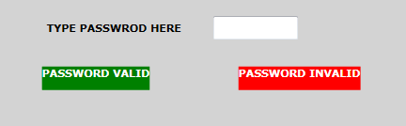

#### Notes

### Maintain Vending Machine Use Case *(SRS_REQ_400)*



Figure : Maintain Vending Machine Use Case

#### Brief Description

The Maintain Vending Machine Use Case provides the capability to maintain the VM.

#### Characteristic of Activation

The Maintain Vending Machine Use Case is initiated by the maintainer.

#### Pre-Condition

1. The maintainer should be authenticated.
2. The door must be unlocked.

#### Description

##### Basic Flow

#### The Maintain Vending Machine Use Case starts when the MIP is activated.

1. Once the MIP is activated the VMCS will allow the maintainer to request the following operations:

**[A1] - Display the number of drinks for each brand**

**[A2] - Display money in selected denomination**

**[A3] - Display total money held**

**[A4] - Collect all the cash**

**[A5] - Update price of selected brand**

**[A6] - Update number of drinks**

**[A7] - Update money denominations**

**[A8] - Change door status from unlock to lock**

**[A9] - Exit Maintainer Interface Panel**

1. The Maintain Vending Machine Use Case ends here.

##### Alternative Flow

**[A1] - Display the number of drinks for each brand *(SRS_REQ_401), (SRS_REQ_412)***

1. The VMCS will display total number of can of each brand in MISP.
2. The Maintain Vending Machine Use Case continues.

**[A2] - Display money in selected denomination *(SRS_REQ_402), (SRS_REQ_408)***

1. The maintainer selects the denomination from Maintainer Interface Panel.
2. The VMCS will display total amount of money for selected denomination in Maintainer Interface Panel.
3. The Maintain Vending Machine Use Case continues.

**[A3] - Display total money held *(SRS_REQ_403), (SRS_REQ_410)***

1. The maintainer presses the “TOTAL CASH” button in Maintainer Interface Panel.
2. The VMCS will display total cash which is held in all denominations to the maintainer.
3. The Maintain Vending Machine Use Case continues.

**[A4] - Collect all the cash *(SRS_REQ_404)***

1. The maintainer presses the “COLLECT ALL CASH” button in Maintainer Interface Panel.
2. The VMCS will dispense all the cash. ***(SRS_REQ_411)***
3. The Maintain Vending Machine Use Case continues.

**[A5] - Update price of selected brand *(SRS_REQ_409)***

1. The maintainer selects a brand.
2. The maintainer updates the price of selected brand on Maintainer Interface Panel.
3. The Maintain Vending Machine Use Case continues.

**[A6] - Update number of drinks *(SRS_REQ_406), (SRS_REQ_417)***

1. The maintainer updates number of the cans for each brand on MISP.
2. The Maintain Vending Machine Use Case continues.

**[A7] - Update money denominations *(SRS_REQ_407)***

1. The maintainer updates the number of money for each denomination on MISP.
2. The Maintain Vending Machine Use Case continues.

**[A8] - Change door status *(SRS_REQ_413)***

1. The maintainer presses the “LOCKED” button on the MISP when the maintainer wants to exit. ***(SRS_REQ_405)***
2. Once the “LOCKED” single received, the VMCS will:
   1. Enables the following:
      1. “ACTIVATE CUSTOMER INTERFACE PANEL” button.
      2. Authentication mechanism
   2. Disables the following:
      1. “ACTIVATE MACHINERY INTERFACE SIMULATION PANEL” button.
3. The Maintain Vending Machine Use Case ends here.

**[A9] - Exit Maintainer Interface Panel**

1. Once the maintainer press the “FINISHED” on the MIP, the VMCS will display OSCP.
2. The Maintain Vending Machine Use Case continues.

##### Exception Flow

Not applicable

#### Post-condition(s)

1. At the end of the Maintain Vending Machine Use Case the VMCS should be updated. ***(SRS_REQ_407), (SRS_REQ_415), (SRS_REQ_416), (SRS_REQ_419)***

#### Rule(s) and Constraint(s):

1. The number of drink cans must be between 0 and 20.
2. The number of coins in each denomination must be between 0 and 20.
3. The customer cannot trigger Buy Drinks Use Case while maintenance is in the progress.

#### GUI

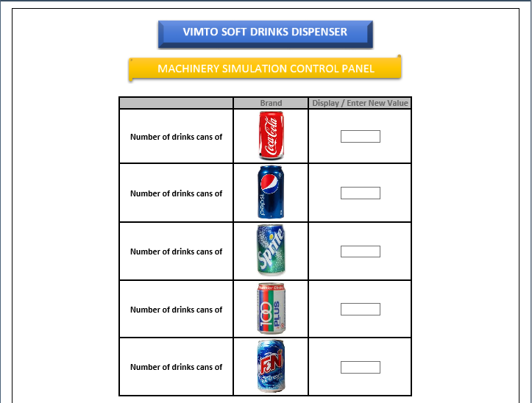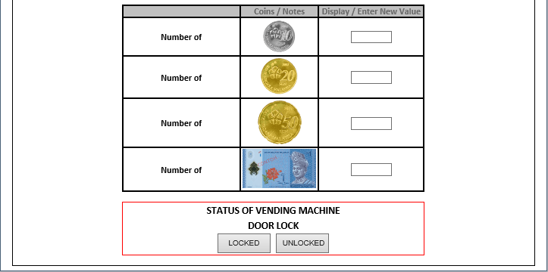

#### Notes

# CSCI Internal Interfaces



Figure : VMCS Class Diagram

## CSCI Data Element Requirements

This paragraph identifies the interfaces between the capabilities identified above. In this case, this means that we give the main activity, the list of the classes, messages of each class according to an object-oriented point of view.

### Boundary Classes

#### MISP

Responsibilities :

Message

:

#### MIP

Responsibilities :

Message

:

#### OSCP

Responsibilities :

Message

:

#### Vending Machine Door

Responsibilities :

Message

:

#### CIP

Responsibilities :

Message

:

#### Drink Dispenser

Responsibilities :

Message

:

#### Money Slot

Responsibilities :

Message

:

#### Change Dispenser

Responsibilities :

Message

:

### Entity Classes

#### Money Storage

Responsibilities :

Message

:

#### Drink Storage

Responsibilities :

Message

:

#### Money Denomination

Responsibilities :

Message

:

### Control Classes

#### VMCS

Responsibilities :

Message

:

#### Authentication

Responsibilities :

Message

:

## Adaptation Requirements

Not applicable

## Sizing and Timing Requirements

Not applicable

## Safety Requirements

Not applicable

## Security Requirements

Not applicable

## Design Constraints

OOAD using UML notation

## Requirements Traceability

| **Source** | **Requirements** | **#** | **Description** | | **Priority** | **Note** |
| --- | --- | --- | --- | --- | --- | --- |
| **Buy Drinks Use Case** | | | | | | |
| URSPVMCS V 1.0 | Select drink | SRS_REQ_201 | The Customer must be able to select drinks before any money can be entered into the VM. | Mandatory | CIP | |
| Terminate transaction | SRS_REQ_202 | The Customer must be able to terminate transaction at any point of time | Mandatory | CIP | |
| Accept money | SRS_REQ_203 | There should be a facility to accept the money from the customer. | Mandatory | CIP | |
| Display price | SRS_REQ_204 | The CIP shall display price for selected brands to the customers. | Mandatory | CIP | |
| Display availability | SRS_REQ_205 | Once the customer selects a brand the CIP shall display availability of the selected brand to the customer. In case of unavailability of the brand the CIP shall display appropriate message, and shall wait for the customer to choose a available drinks brand. | Mandatory | CIP | |
| Calculate total accumulated money | SRS_REQ_206 | The CIP shall display total amount of accumulated money to the customer in any time during the transaction. | Mandatory | - | |
| Display not enough money | SRS_REQ_207 | The CIP shall display appropriate message to the customer when there was not enough coins of appropriate denominations. | Mandatory | CIP | |
| Validate money | SRS_REQ_208 | The VMCS shall validate inserted money. | Mandatory | - | |
| Display accumulated money | SRS_REQ_209 | The CIP shall be able to display total accumulated money. | Mandatory | CIP | |
| Reject invalid money | SRS_REQ_210 | The CIP shall be able to reject not valid money. | Mandatory | CIP | |
| Display not valid money | SRS_REQ_211 | The CIP shall display appropriate message to the customer in case of rejection of the invalid money. | Mandatory | CIP | |
| Return money to the customer | SRS_REQ_212 | The CIP shall return the money to the customer in case of termination of transaction by customer. | Mandatory | CIP | |
| Dispense change | SRS_REQ_213 | The CIP shall dispense the appropriate change to the customer. | Mandatory | CIP | |
| Monitor total accumulated money | SRS_REQ_214 | The VMCS shall monitors accumulated money to the customer during transaction. | Mandatory | - | |
| Evaluate total accumulated money | SRS_REQ_215 | The VMCS shall determines whether enough money has been inputted by the customer or not | Mandatory | - | |
| Disable money slot | SRS_REQ_216 | The VMCS shall disable the money slot if TOTAL_ACCUMULATED_MONEY >= SELECTED_PRICE has been inputted | Mandatory | - | |
| Enough money to purchase | SRS_REQ_217 | The VMCS shall determine whether inputted money is enough for selected purchase or not. In case of insufficient money VMCS shall not respond to the customer request and should wait for further from customer | Mandatory | - | |
| Determine amount of change | SRS_REQ_218 | The VMCS shall determine if any change should be sent to the customer. | Mandatory | - | |
| Interview with customer | Store successful record | SRS_REQ_219 | The VMCS shall keep the record of successful transactions until end of simulation. | Mandatory | - | |
| **Login Use Case** | | | | | | |
| URSPVMCS V 1.0 | Login to VMCS | SRS_REQ_301 | The Maintainers shall identify their self to the VMCS using an authorized password. | | Mandatory | MIP |
| Authentication | SRS_REQ_302 | The maintainer shall enter the correct password in order to start maintenance. | | Mandatory | MIP |
| Receive password | SRS_REQ_303 | The MIP shall receive the password from the maintainer. | | Mandatory | MIP |
| Authenticate maintainer | SRS_REQ_304 | The VMCS shall validate maintainer. | | Mandatory | - |
| Unlock door | SRS_REQ_305 | The VMCS shall unlock the door once the correct password is received. | | Mandatory | MISP |
| Lock CIP | SRS_REQ_306 | The VMCS shall not begin any customer transactions whilst the maintainer is operating upon it. | | Mandatory | - |
| Rollback customer request | SRS_REQ_307 | The VMCS shall terminate and refund all the money to the customer provided that during transaction the maintainer attempts to log in to the MIP. | | Mandatory | - |
| **Maintain Vending Machine Use Case** | | | | | | |
| URSPVMCS V 1.0 | Selected brand query | SRS_REQ_401 | The maintainer shall be able to see the numbers of drink cans held for any particular brands on request. | | Mandatory | MISP |
| Selected denomination query. | SRS_REQ_402 | The maintainer shall be able to see amount of money held in each denomination on request | | Mandatory | MIP |
| Money query | SRS_REQ_403 | The maintainer shall be able to see total money held by VMCS on request. | | Mandatory | MIP |
| Collect all cash | SRS_REQ_404 | The maintainer shall be able to transfer all cash held within the VM on request. | | Mandatory | MIP |
| Terminate the transaction | SRS_REQ_405 | The maintainer shall be able to terminate the transaction by locking the door. | | Mandatory | MIP |
| Change cans number | SRS_REQ_406 | The maintainer shall be able to change the number of the cans that held by the machine provided that the door has been already unlocked by the lock/unlock mechanism. | | Mandatory | MIP |
| Change denomination | SRS_REQ_407 | The maintainer shall be able to change the amount of the money that held by the machine provided that the door has been already unlocked by the lock/unlock mechanism. | | Mandatory | MIP |
| Display total money held per denomination | SRS_REQ_408 | The MIP shall display total money held in selected denomination on request. | | Mandatory | MIP |
| Update price | SRS_REQ_409 | The MIP shall update price for selected brand on request. | | Mandatory | MIP |
| Display total money held in VM | SRS_REQ_410 | The MIP shall display total money held in VM on request. | | Mandatory | MIP |
| Dispense money | SRS_REQ_411 | The MIP shall dispense all the money to the maintainer on request. | | Mandatory | MIP |
| Display number of drinks | SRS_REQ_412 | Machinery MISP provides a facility to display numbers of drink for each brand. | | Mandatory | MISP |
| Lock the door | SRS_REQ_413 | There shall be a facility to lock the door of VM. | | Mandatory | MISP |
| Monitor drink storage | SRS_REQ_414 | Machinery Simulator Panel shall monitor number of drinks from each brands | | Mandatory | - |
| Discard terminated transaction | SRS_REQ_415 | The VMCS shall not keep any record in case of termination of the transaction. | | Mandatory | - |
|  | Monitor total cash held within VM’s denominations | SRS_REQ_416 | The VMCS shall monitors total amount of cash held within the VM | | Mandatory | - |
| Update drink storage | SRS_REQ_417 | The VMCS shall monitor status of the cans once the maintainer transaction has ceased. | | Mandatory | - |
| Interview with customer | Update money denomination | SRS_REQ_418 | The VMCS shall monitor status of denomination once the maintainer transaction has ceased. | | Mandatory | - |
| **Simulate Control Panel Use Case** | | | | | | |
| URSPVMCS V 1.0 | Begin simulation | SRS_REQ_101 | The OSCP shall provide facility to begin simulation. | | Mandatory | OSCP |
| End simulation | SRS_REQ_102 | The OSCP shall provide facility to end simulation. | | Mandatory | OSCP |
| Activate CIP | SRS_REQ_103 | The OSCP shall provide facility to activate CIP. | | Mandatory | OSCP |
| Activate MIP | SRS_REQ_104 | The OSCP shall provide facility to activate MIP. | | Mandatory | OSCP |
| Activate MISP. | SRS_REQ_105 | The OSCP shall provide facility to activate MISP. | | Mandatory | OSCP |

Table : Traceability Requirements Matrix

# QUALITY ASSURANCE

Not applicable - *for this exercise but during project 2 later, students are required to refer the guideline so that you know what things are supposed to be added in this chapter during the OOA (delete this itallic part and leave alone the words not applicable before submission, fail doing so, your marks will be affected)*

# PREPARATION FOR DELIVERY

The delivery of documents will be delivered in the following formats:

File format : Microsoft Word and Enterprise Architect Models

Submission formats : Hardcopy and Softcopy

Quantity : 1 each

# NOTES

Abbreviation used:

**- AIS** Advanced Informatics School

**- CSCI** Computer Software Configuration Item

**- DOD** Department of Defense

**- IRS** Interface Requirement Specification

**- MIL** Military

- **Std.** Standard

- **IEEE** Institute of Electrical and Electronics Engineers

**- OOAD** Object Oriented Analysis Design

**- SDP** Software Development Plan

**- UML** Unified Modeling Language

**- CIP** Customer Interface Panel

**- MIP** Maintainer Interface Panel

**- MISP** Machinery Interface Simulation Panel

**- OSCP** Overall Simulation Control Panel

**- VMCS** Vending Machine Control System

**- VM** Vending Machine

**- URSPVMCS V 1.0** USER REQUIREMENTS SPECIFICATION for VENDING MACHINE CONTROL SYSTEM (Version 1.0)

# ANNEX



Figure : Buy Drinks Sequence Diagram



**Figure 9: Login Sequence Diagram**



**Figure 10: Maintain Vending Machine Sequence Diagram**



**Figure 11: Simulate Control Panel Sequence Diagram**



**Figure 12: Buy Drinks Sequence Diagram**

**Figure 13: Buy drinks Activity Diagram**



**Figure 14: Login Activity Diagram**



**Figure 15: Maintain Vending Machine Activity Diagram**



**Figure 16: Drink query Activity Diagram**



**Figure 17: Update price Activity Diagram**



**Figure 18: Total money query Activity Diagram**



**Figure 19: Collect all cash Activity Diagram**



**Figure 20: Update drinks Activity Diagram**



**Figure 21: Denomination query Activity Diagram**



**Figure 22: Update denomination Activity Diagram**



**Figure 23: Update VMCS Activity Diagram**



**Figure 24: Update denomination Activity Diagram**



**Figure 25: Update VMCS Activity Diagram**



**Figure 26: Simulate Control Panel Activity Diagram**



**Figure 27: Begin Simulation Activity Diagram**

**This page** **intentionally left blank**